A Commissioning Prayer
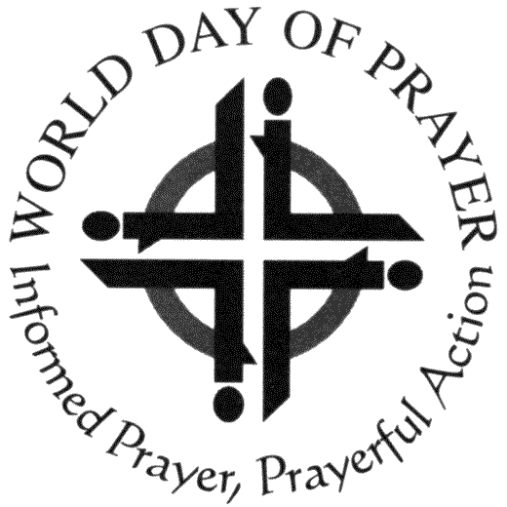

For use at the end of the service
Scottish charity number SC 020446

At the end of the service (immediately prior to the Benediction Sending and Blessing), pass a lighted candle to a representative of next year’s host church and say the following prayer:

Heavenly Father, we thank you for the World Day of Prayer which is taking place throughout the world today, and has been prepared by the Christian women of...............................................................(Enter the writing country).
Many Christians gather together to praise you and we thank the Priests/ Ministers/ Pastors (Delete as appropriate) and people of ……………………………………………….…. (Host church) for hosting this world-wide service of Prayer in.................... (Year)

With joy we pass this candle to……………………………………………..… (rep.’s name), who represents …………………………………………………………………. (Next host church) who will host next years’ service, prepared by the Christian women of............................................... (Writing country).

Some groups have used this and find it very meaningful and helpful

This liturgy is used by kind permission of EWNI World Day of Prayer

